**Employee Data Analysis using Excel**

STUDENT NAME:Sandhiya.S

REGISTER NO:312215868

DEPARTMENT:B.Com (Accounting and finanace)

COLLEGE-Shri Shankarlal Sundarbai shasun Jain college for womens

**PROJECT TITLE**



**Employee Performance**

**Analysis using Excel**

3

/21/2024

**Annual Review**



**AGENDA**

1.

Problem Statement

2.

Project Overview

3.

End Users

4.

Our Solution and

Proposition

5.

Dataset Description

6.

Modelling Approach

7.

Results and Discussion

8.

Conclusion

# PROBLEM STATEMENT

# As an HR Analyst,you have beentasked with evaluation the performance of employees in a large organisations.you have access to a database containing employees information, including

* Employee Id
* Name
* Department
* Performance Rating(1-5)for past3 year
* Salary
* Years of service

Naa



# PROJECTOVERVIEW



1. Identify top performance employees across department
2. Determine the relationship between performance Rating and salary
3. Examine the impact of years of service on performance Rating
4. Develop a dashboard to visualize key performance metrics
5. Provide recommendations for talent development and retention strategies.

**WHO ARE THE END USERS?**

1. **HR Manager -**Responsible for talent development and performance management.
2. **Department Head-**Leader of various departments who need to understand their team performance.
3. **Senior Management -**Executed who require insights to inform strategic decision on talent development, resources allocation and etc..
4. **Team Lead-**Supervisor who need to understand their team member strength and weakness to provide target coaching.
5. **Employees-** Individual who want to understand their own performance,set goals,and track progress.

## OUR SOLUTION AND ITS VALUE PROPOSITION

**Solution**

* Comprehensive Excel-base employees performance analysis and visualization tool
* Automated data cleaning, processing and analysis

**Value prositions**

* Data-driven insights.Make informed decisions about talent development, performance management.
* Improve performance management.Identify areas for improvement set target goal and track progress.

# Dataset Description

**Description -**This dataset contains employees performance data for long organization including

* **Employee ID-** unique identifier for each employee
* **Name**-Employee name
* **Department -**Department or team the employee belong to
* **Job Title-** Employee ‘s job title
* **Performance -**Annual performance rating 1-5
* **Salary -**Annual salary
* **Age-**Employee age
* **Gender-**Employee gender
* **Education level-**Highest level of education Complete

## THE "WOW" IN OUR SOLUTION

* **Forecasting future performance –** Idendentify high-potential employees and predict future performance based on historical data and trends
* **Detect early warning sign -**Flag employee at risk of underperforming
* **Personalized development plans-**Generate tailored devlopment recommendations for each employee,aligning with their strength and weakness.
* **Automated coaching insights -**provide manager with data driven coaching suggestions to improve employee performance and address skill gaps.

3

/21/2024

**Annual Review**



**MODELLING**

**Modelling approach**

* **Descriptive Analysis:**
* Data cleaning and pre-processing
* Data visualization
* Summary statistics
* **Inferential Analytics**
* Correlation analysis
* Regression analysis
* Hypotheses testing
* **Predictive Analytics**
* Optimization techniques
* Simulation modeling

# RESULT S

**Formula:**

**=IFS(Z8>=5,"VERY HIGH",Z8>=4,"HIGH",Z8>=3,"MED",TRUE,"LOW")**

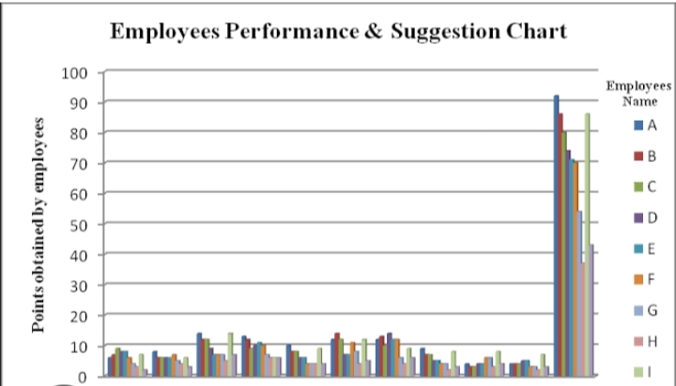

**Conclusion**

The employee performance analysis using Excel has provided valuable

Insights into the organisation talent landscape

1. Identified top performance and underperforming employees
2. Uncovered department and demographic trends influencing

Performance

3. targeted recommendations for talent development